* **Destructing** **objects means to** create new variables, and use assignments to set their values to specific elements of an object.

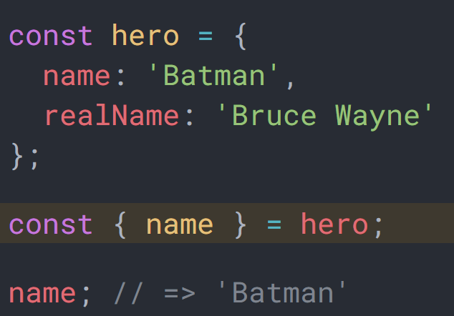

* **Destructing** allows extracting more than one element from the object.

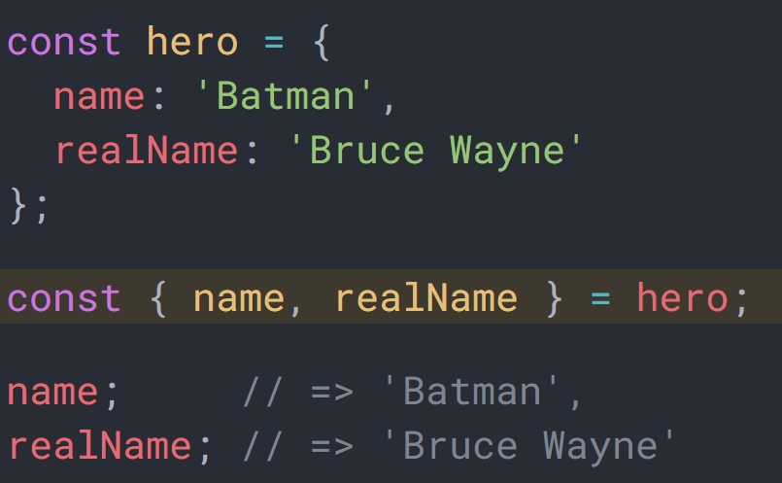

* The variable names should exist in the object. Otherwise it will be undefined.

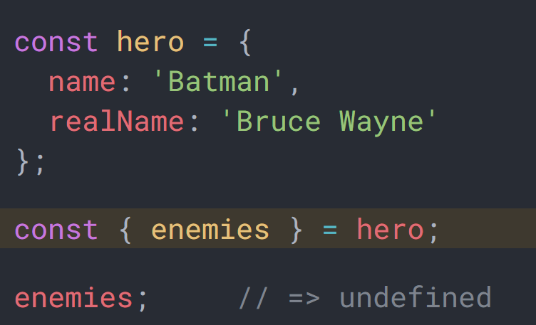

* It is allowed to change the name of the variable to be any name other that the property of the object by using **aliasing** which means give a variable different names at once.

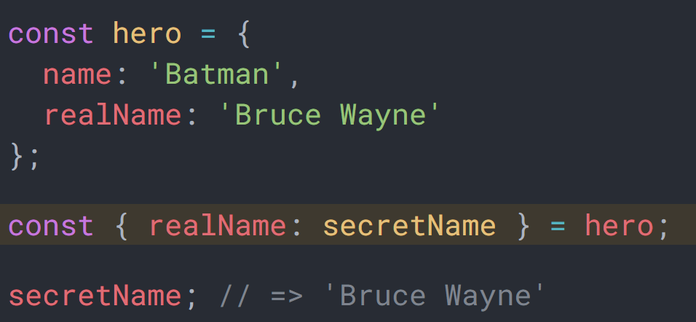

* If you have nested object, you can destruct its properties too.

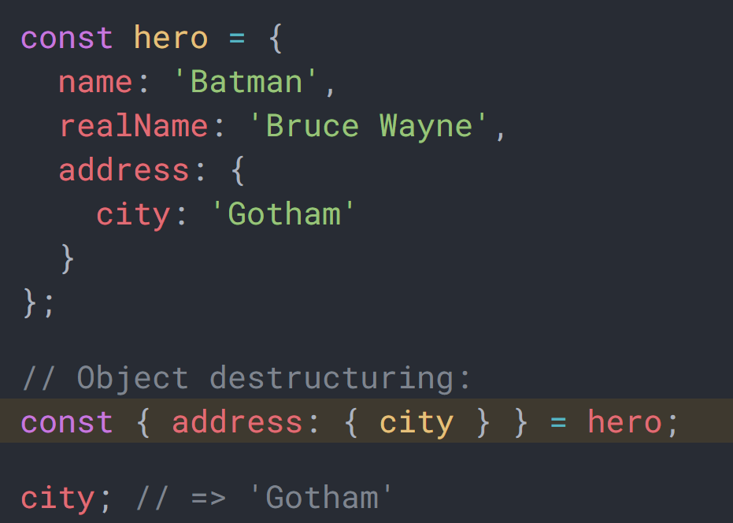

* It is allowed to destruct to an already defined variable.

